

KURO – Information for invitation to tender

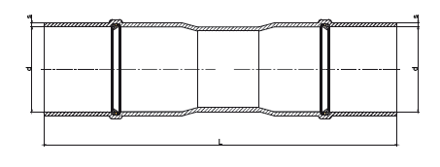
Product:

PVC double sealing socket with inner ring

Information for invitation to tender:

 | Pos:....................... | PVC double sealing socket with 2 seal rings
 |  | Colour: black110 x 3,2 mm / Length = 410 mm
 |  | System KURO o. glw. (www.kuro-kunststoffe.de),
 |  | supply and install, as an addition to pos: ...........
 |  | Amount:............Pieces UP: ....... TP: ........
 | Pos:....................... | PVC double sealing socket with 2 seal rings
 |  | Colour: black110 x 5,3 mm / Length = 457 mm
 |  | System KURO o. glw. (www.kuro-kunststoffe.de),
 |  | supply and install, as an addition to pos: ...........
 |  | Amount:............Pieces UP: ....... TP: ........
 | Pos:....................... | PVC double sealing socket with 2 seal rings
 |  | Colour: black125 x 3,7 mm / Length = 365 mm
 |  | System KURO o. glw. (www.kuro-kunststoffe.de),
 |  | supply and install, as an addition to pos: ...........
 |  | Amount:............Pieces UP: ....... TP: ........
 | Pos:....................... | PVC double sealing socket with 2 seal rings
 |  | Colour: black125 x 6,0 mm / Length = 365 mm
 |  | System KURO o. glw. (www.kuro-kunststoffe.de),
 |  | supply and install, as an addition to pos: ...........
 |  | Amount:............Pieces UP: ....... TP: ........

 | Pos:....................... | PVC double sealing socket with 2 seal rings
 |  | Colour: black160 x 4,7 mm / Length = 380 mm
 |  | System KURO o. glw. (www.kuro-kunststoffe.de),
 |  | supply and install, as an addition to pos: ...........
 |  | Amount:............Pieces UP: ....... TP: ........

